

**COMSATS University Islamabad (Lahore Campus)**

**<Lab Task 3> – SPRING 2024**

|  |  |  |  |  |  |
| --- | --- | --- | --- | --- | --- |
| Course Title: | Game Development | Course Code: | CSC495 | Credit Hours: | 3 |
| Course Instructor/s: | Saira Aslam | Program | BSE | | |
| **Submission Deadline** | **11:55 pm, 12-3-2024** | **Maximum Marks:** | **50** | | |
| **Important Instructions / Guidelines:**   * Submit a 10 seconds video, 4 screenshots, and all your scripts in Lab Assignment 1 submission at google classroom * Paste your screenshots and scripts inside Lab Assignment-1 submission file provided | | | | | |

***Question No 1.***

***CLO: <3>; Bloom Taxonomy Level: <****Apply****>* [80]**

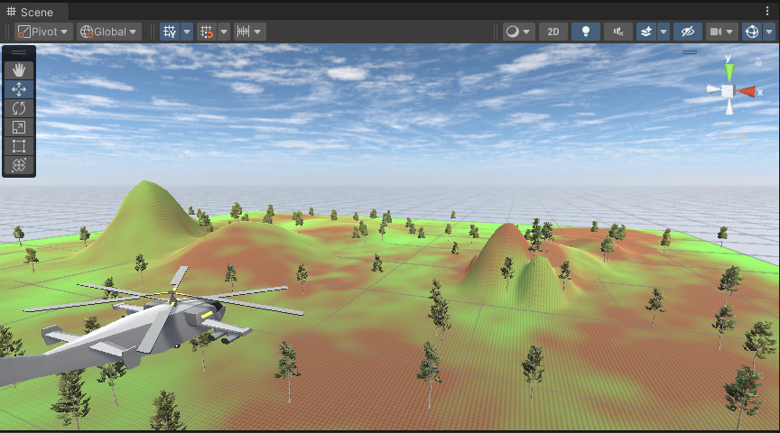

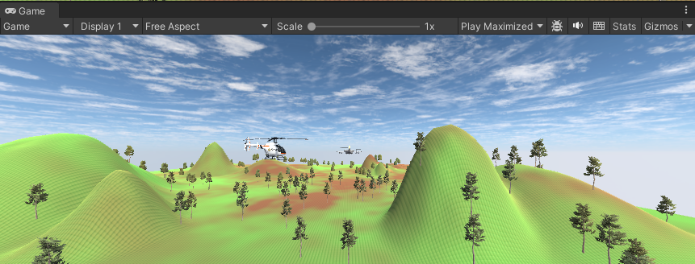

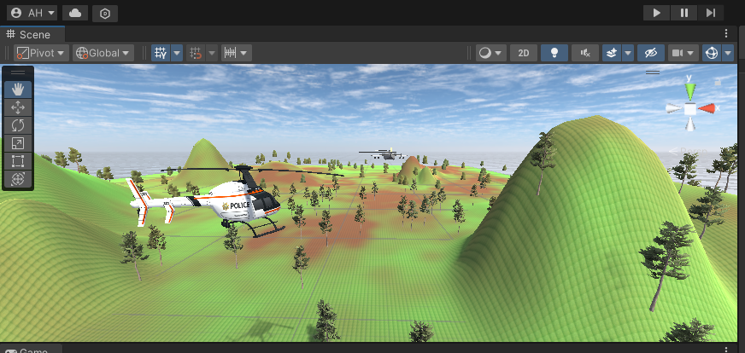

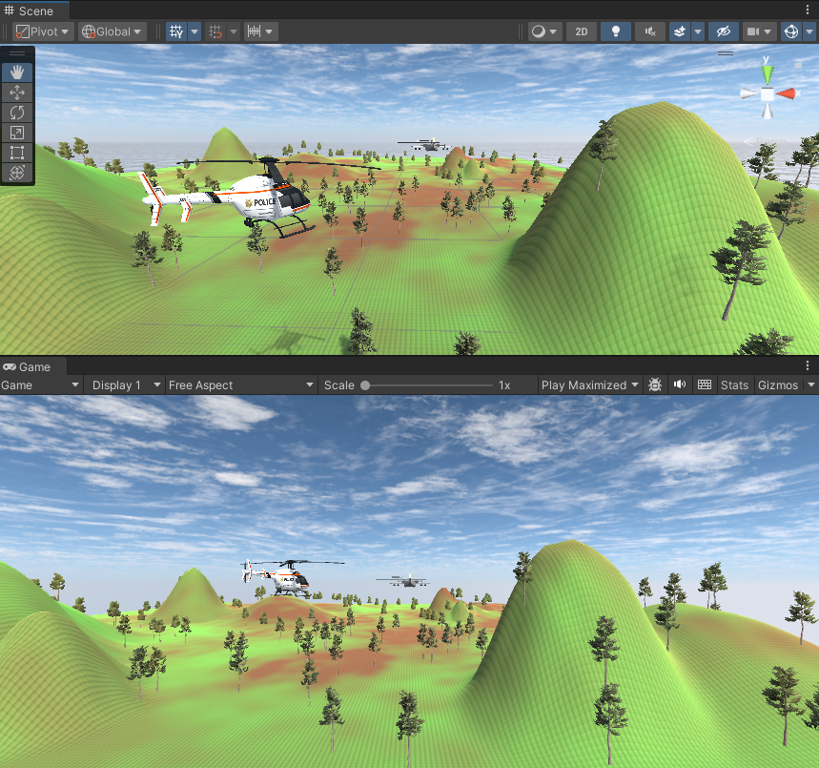

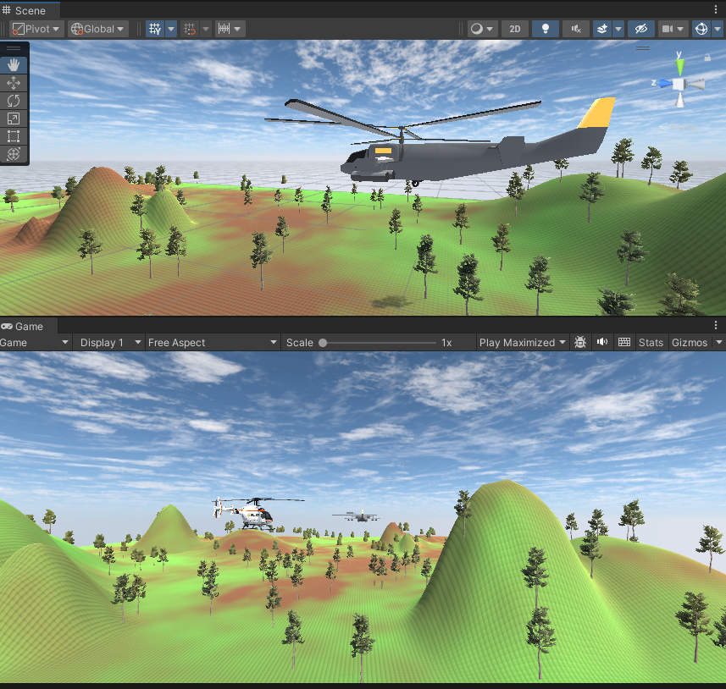

**helliCopterScript.cs**

using System.Collections;

using System.Collections.Generic;

using UnityEngine;

public class hellicopterScript : MonoBehaviour

{

    public GameObject bullet;

    // Start is called before the first frame update

    void Start()

    {

    }

    // Update is called once per frame

    void Update()

    {

        if(Input.GetKey(KeyCode.LeftArrow))

        {

            transform.Rotate(0,-1,0);

        }

        if(Input.GetKey(KeyCode.RightArrow))

        {

            transform.Rotate(0,1,0);

        }

        if(Input.GetKey(KeyCode.UpArrow))

        {

            transform.Translate(0,0,1);

        }

        if(Input.GetKey(KeyCode.DownArrow))

        {

            transform.Translate(0,0,-1);

        }

        if(Input.GetKey(KeyCode.W))

        {

            transform.Translate(0,1,0);

        }

        if(Input.GetKey(KeyCode.S))

        {

            transform.Translate(0,-1,0);

        }

        if(Input.GetKey(KeyCode.Space))

        {

            Instantiate(bullet,transform.position,transform.rotation);

        }

    }

}

**cameraScript.cs**

using System.Collections;

using System.Collections.Generic;

using UnityEngine;

public class cameraScript : MonoBehaviour

{

    public GameObject HeliCopter;

    private Vector3 offset;

    // Start is called before the first frame update

    void Start()

    {

        offset = transform.position - HeliCopter.transform.position;

    }

    // Update is called once per frame

    void Update()

    {

        transform.position = offset + HeliCopter.transform.position;

    }

}

**bulletScript.cs**

using System.Collections;

using System.Collections.Generic;

using UnityEngine;

public class bulletScript : MonoBehaviour

{

    public GameObject explosion;

    // Start is called before the first frame update

    void Start()

    {

    }

    // Update is called once per frame

    void Update()

    {

        transform.Translate(0,0,1);

    }

    public void OnCollisionEnter(Collision col)

    {

        if(col.gameObject.name.StartsWith("Enemy"))

        {

            Destroy(col.gameObject); //destroy the enemy

            Instantiate(explosion,transform.position,transform.rotation);

        }

        Destroy(transform.gameObject); //destroy bullet clone

    }

}

**enemyScript.cs**

using System.Collections;

using System.Collections.Generic;

using UnityEngine;

public class enemyScript : MonoBehaviour

{

    public GameObject enemy;

    // Start is called before the first frame update

    void Start()

    {

        //Vector3 enemyPos = new Vector3(Random.Range(200,100));

    }

    // Update is called once per frame

    void Update()

    {

    }

}